Final Forensic Case Report – Phase 4

Executive Summary
This investigation examined a Windows 11 local host machine which was suspected of being compromised after downloading a suspicious file. Digital evidence was collected including a Disk Image and Memory dump. The analysis revealed that a suspicious file was potentially downloaded, which led to abnormal activity. Evidence from the disk and memory dump led to this conclusion.

Incident Overview
The focus of this investigation was a Windows 11 local machine, which was used to simulate a potential security incident.
This involved:
- Downloaded a suspicious file
- Executing a file
- Creating activity
The scope of this investigation was the Image.ad1 disk image file and physmem.raw memory dump file.

Evidence Summary
All evidence was hashed using SHA-256 in order to ensure data integrity.

Evidence #1
- Evidence ID: 1
- Description: Disk Image
- Date/Time Acquired 4/21/26 3:08 PM EST
- Hash: c13873ac5f81932d3f4118454c012bc4642187827a1784f03cefcb41b25c0
- Storage Location: /home/wendel/evidence
- Acquired using FTK Imager

Evidence #2
- Evidence ID: 2
- Description: Memory Dump
- Date/Time Acquired 4/21/26 3:02 AM EST
- Hash: f29035292d47d3f667ee7411f7e0a9226589dc1440538cd74c3bcc23902f3994
- Storage Location: /home/wendel/evidence/physmem.raw
- Acquired using WinPmem

Methodology
The tools used for analysis include Autopsy, Volatility, and FTK Imager. Autopsy was chosen to analyze the files within the disk image. Volatility was chosen to analyze the memory dump. Due to storage limits, a logical disk acquisition was done, only acquiring data from the suspicious folder.

Detailed Findings

File Image analysis revealed:
- File downloads:
Unknown exe files were found in C:\Users\wende\Desktop\SUSPICIOUSFOLDER
(KiloHearts Installer.exe, parsec-windows.exe)
The parsec-windows.exe is likely the origin of the compromise and was interpreted as malware.
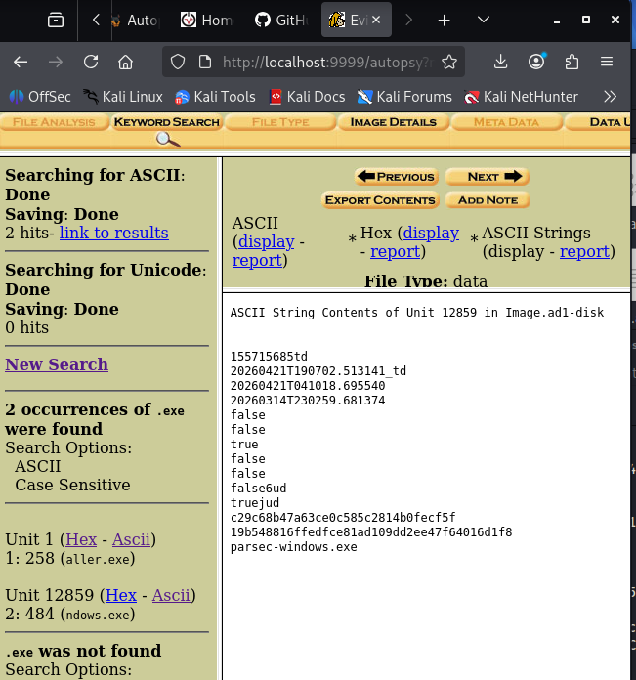

Memory Analysis reveals:
- Multiple Suspicious .exe being ran
Greenshot.exe
atieah64.exe
aimgr.exe
ai.exe
AUEPDU.exe
These files were interpreted as suspicious due to their unknown nature.
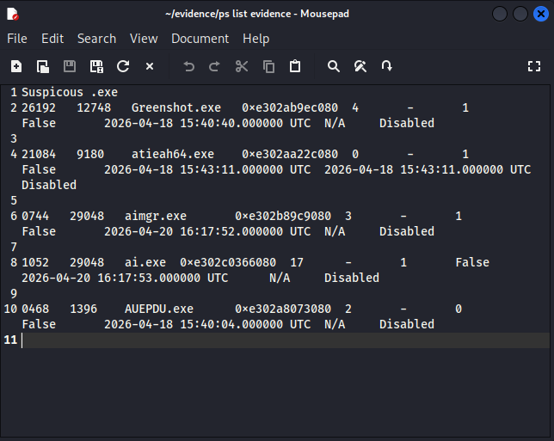
An additional scan was done where the parsec-windows.exe was ran through VirusTotal and flagged as malicious, increasing the likelihood that this was the source of malware. 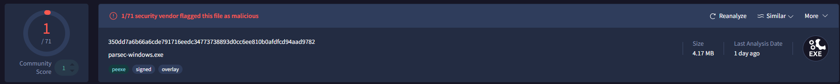

Timeline Reconstruction
This timeline shows when the exe files were initially ran.
4/18/26 15:40:04 AUEPOU.exe
4/18/26 15:40:40 Greenshot.exe
4/18/26 15:43 atieah64.exe
4/20/26 16:17 aimgr.exe
4/20/26 16:17 ai.exe

Conclusion and Assessment
- This investigation concluded that the system was compromised after downloading the parsec-windows.exe unauthorized file from the internet.
- The VirusTotal Flag and presence of suspicious files and .exe files led to this conclusion.
- Confidence level is Moderate to High
- The user should install and run anti-virus software and avoid downloading untrusted files.

